

**CHALKTALK: INTERNSHIP RECOMMENDER SYSTEM**

A Capstone Project

Presented to the Faculty of the

Polytechnic University of the Philippines

Quezon City Branch

In Partial Fulfillment of the Requirements for the Degree

Bachelor of Science in Information Technology

By

Magtibay, Joshua Miguel P.

Gabriel, Oliver J.

Asusula, Mary Joy

Teneza, Peter John

Alvior, Keith Eyvan

Agnir, Lowell Dave

**NOVEMBER 2018**

**1.0 Project Background 4**

**1.1 Project Charter 4**

**1.2 Project Plan 11**

1.2.1 Project Timeline 13

1.2.2 Risk Management Plan 14

**1.3 System Architecture (Top Level View) 16**

1.3.1 Business Process Architecture 19

1.3.2 Application Architecture 20

1.3.3 Data Architecture 21

1.3.4 Technology Architecture 22

**2.0 Product Backlog 23**

**2.1 Product Backlog (User Stories) Table 23**

**2.2 Product Backlog for EIS Information Security 24**

**2.3 Product Backlog for EIS Standards 25**

2.3.1UI/UX (icons, color, etc) 26

2.3.2Messages 29

2.3.3Database 30

**2.4 Product Backlog for EIS Integration 31**

**2.5 Product Backlog for Analytics 32**

2.5.1 Dashboards 32

2.5.2 Reports 33

**3.0 Sprint Backlog 34**

**3.1 Sprint Backlog (User Stories) Table 34**

3.1.1 Information Security 35

3.1.2 EIS Standards 36

3.1.3 EIS Standards 37

3.1.4 Analytics 38

**3.2 Sprint Burndown Chart 39**

**3.3 Sprint Backlog Output 40**

3.3.1 Requirement Traceability Matrix 40

3.3.2 Data Dictionary 41

3.3.3 Test Scripts 42

3.3.4 System Screenshots 43

**4.0 Application System User Manual 44**

**5.0 Recommendations and Conclusion 45**

**Appendix A 46**

**Appendix B 47**

**Appendix C 48**

**Appendix D 49**

**Appendix E 50**

**Appendix F 52**

**Appendix G 53**

1. **Project Background**
   1. **Project Charter**

**Table 1**

Project Charter

|  |  |
| --- | --- |
| **Project:** | ChalkTalk: Internship Recommender System |
| **Date:** | Revised as of October 20, 2018 |
| **Author:** | ChalkTalk: IRS Project Team |
| **Mission** | ChalkTalk: Internship Recommender System’s goal is to help the interns, host training establishments and schools to find the compatible internship trainings, partnership and available business enterprises. |
| **Vision** | To develop a system that can help the interns, host training establishments and schools to find the compatible internship trainings, partnership and available business enterprises. Through the development of web application, the management services and the beneficiary of this system will be done in less effort, giving them fast and reliable services. |
| **Objective** | The objective of the project will be discussed in terms of modular division. The following objectives is based on the project team’s understanding of the business process, therefore, using it as a basis for creating the technical view of objectives of the system.  ChalkTalk: Internship Recommender System is a sytem that intents to help interns, host training establishments and schools to acquire their goals and objectives easier. ChalkTalk: Internship Recommender System is composed of two (2) core modules. |
| **Project Size Estimate** | Given the timeline to finish the system that the organization has started to complete last August 27, 2018 until by October, the end of semester, the estimated cost in developing the project ranges from PHP 8,000 – 12,000, allotted budget to be used for vehicle fare every time the scrum master and/or project team needs to interview the client and/or for user acceptance (also to the client) every after 2 weeks, and for other miscellaneous fees. As mentioned above, August to October.  Basically, we only have 6-8 weeks duration to build the project. And approximately 4-6 persons in the development team. The project should have a progress every single day if possible. |
| **Project**  **Complexity Estimate** | Upon building the project, it might have some conflict that can affect to the target period of time in completing the system. The developers might not be able to make it on the due date if one is sick or has an emergency issue. In that case, the project completion might either move or will not be finish at all.  Another risk that the organization might encounter is the lack of communication between the developer, tester and/or QA, including the client. The system might not turn out to be what everyone wants it to be if there is no established standard for creating the project.  These estimated project complexities are not easy to deal with. Any risk that doesn’t have a backup plan if these happen, or absolute support to be called on if necessary can have a worst impact in developing the project. As we concluded, it might lead to dropping the whole project. |
| **Scope** | The project development has started by the 27th of August, 2018 and is assumed to be completed by the end of October, 2018. The organization aims to produce an easy to use, engaging, and user-friendly, innovative system that any insurance company can use in achieving highest possible quality of service for their clients. This project includes a web-based system and a complete project documentation. The project development has started by the 27th of August, 2018 and is assumed to be completed by the end of October, 2018. The project shall include a web-based system and a full documentation – inclusive of a user’s manual, project management plan, and software requirements and design specifications.  The objectives of the project are to gather data from its selected client to be able to conduct analysis and to come up with the design and features of the future ChalkTalk: Internship Recommender System.  The project will be written using Laravel Framework, a framework that helps software developers create dynamically generated web pages following the model-view-controller architectural pattern, that uses PHP programming language, and PHPStorm as the IDE or Integrated Development Environment, MySQL for the database and Hostgator Web Hosting to implement Laravel Framework and PHP. |
| **Organization** | Here are the following people in the organization behind the project:  **Professor Rosicar Escober –** Guide or Adviser, QA, respective client of ChalkTalk: Internship Recommender System, **project sponsor**, Tester of Hotel Enterprise Information System.  **Mr. Joshua Miguel Magtibay –** Scrum Master, Business Process Analyst, Document Analyst and Full-Stack Developer  **Mr. Oliver Gabriel –** Full-Stack Developer, Database Administrator, UI/UX Designer  **Ms. Mary Joy Asusula –** DocumentAnalyst, QA, Tester  **Mr. Peter John Teneza –** QA, Tester, UI/UX Designer, Document Analyst  **Mr. Keith Eyvan Alvior –** Tester, QA, Document Analyst  **Mr. Lowell Dave Agnir –** Tester, QA, Document Analyst |
| **Resources** | **Professor Rosicar Escober -** as the guide/adviser, QA and tester, the overall head of our project. She is the one who checks everything, from the start to the end, from the progresses and failures. She advises us of what is and what’s not. The one who gives us motivations and moral support. Also, the chosen client for our project entitled ChalkTalk: Internship Recommender System.  **Mr. Joshua Miguel Magtibay -** TheScrum Master, Business Process Analyst, Full-Stack Developer and Document Analyst together with his members Oliver Gabriel, Mary Joy Asusula, Peter John Teneza, Keith Eyvan Alvior, and Lowell Dave Agnir. And of course, with the participation and guidance of our guide, adviser and our project sponsor, Professor Escober.  From school to our own respective homes, to our client and everywhere else we could do and continue doing the project are the spaces we need. Equipment such as Wireless Fidelity, laptops/desktops, phones, cellphone loads, and software technology like PHPStorm, PHP, Laravel Framework, MySQL and Hostgator Web Hosting, and Trello as medium of communication (and/or Yahoo or Gmail for personal emails) are other things we also need for us to be able to complete this project. It might be a simple thing, but we also recognize Google and other browser for searching, and Microsoft Word for documenting. We will also be needing a printer for printing our documents and other small but too important things like money or funds. |
| **Approaches** | Agile Development Methodology is used in the ChalkTalk: Internship Recommender System development. The Scrum Master will be managing the development and produce output depending on the stakeholder. The team were given two (2) weeks’ time to accomplish task given by the scrum master.  With this method, stakeholder/s can grasp progress with the product. The Scrum Master present the product to the client every two (2) weeks and gather suggestion to make the system functional in accordance to stakeholder’s desire.  The team are composed of Database Administrator for the database design and querying, Developers for execution of the process in the system, Quality Assurance to ensure the documentation and system’s quality, Documentation Team to provide written documentation of system, and Scrum Master to organize the team to product the output that the stakeholder desire |
| **Success Criteria** | 1. Profound understanding of the requirements, business processes, project scope, and goals and objectives. 2. Good communication and teamwork amongst the internal and external project members. 3. Proper management (planning, control, and coordination during execution) including timely, clear, and concise instructions and announcements. 4. Equipment, resources, fund and reasonable time frame for project initiation to project closeout including adjustment resources for new and/or modified requirements. 5. High-level discipline and skills of project team members in documentation and development. 6. Adequacy of the software to the needs of the users.   As long as the system works properly before the semester ends, we can conclude that the project is definitely successful. However, it has to be accepted and approved by the client, Professor Escober. |
| **Product Road Map** | The ChalkTalk: Internship Recommender System is aiming to achieve stakeholder’s desire while ensuring the quality of the system. |
| **Assumptions and Constraint** | **Process**  System’s process must align to the stakeholder’s user stories.  Changing the system’s process without client’s approval is restricted.  **Product**  The product must be functional and efficient to use  Ensuring the quality in the development is a must  The output of the project must meet the stakeholder’s needs.  **Schedule**  The team member must inform the scrum master if the schedule is complicated |
| **Sign-off** | The team will provide an acceptance test every two (2) weeks. This test will require the participation of client to check if the organization’s requirement match with the system functionalities. Once the client approved the system presentation, he/she will have to sign the acceptance letter justifying that the system aligns with the requirements they agreed.  Product’s acceptance letter is also provided at the end project to ensure that the product meet all the requirements provided by the stakeholder. This will also serve as a proof that the project is ready for deployment and the project is completed. |

* 1. **Project Plan**

**Project Name** ChalkTalk: Internship Recommender System

**Project Manager** Joshua Miguel Magtibay

**Project Deliverable** A deliverable is any tangible, measurable outcome of a project. An objective may consist of a single deliverable, or it may contain a series of deliverables.

**Scope Statement**

Start Date August 27, 2018

End Date November 10, 2018

**Table 2**

Objective 1 – Internship Training Recommender Services

|  |  |
| --- | --- |
| PROJECT DELIVERABLE | WORK PRODUCTS/DESCRIPTION |
| Intern Finder | 1. To create a system that will allow host training establishments to find potential interns through the provided web-based system, based on location, educational background, skills, general point average, and state university/college of the intern. 2. To create a system that will allow host training establishments to choose qualified intern applicants for internship training. |
| Host Training Establishment (HTE) Finder | 1. To create a system that will allow interns to find host training establishments which will address their needs in the internship training, through the provided web-based system. It will be based on the location and skills, mixed with the educational background of the intern. 2. To create a system that will allow interns to submit application to the host training establishments which is intelligently recommended by the system, or according to the intern’s preferred host training establishment. |
| Coordinator Services | 1. To create a system that will allow OJT Coordinator(s) to look for other possible host training establishments link to other State Universities and Colleges for better partnerships. 2. To create a system that will intelligently suggest different host training establishments engaged in other State Universities and Colleges. |

**Table 3**

Objective 2 – Internship Management Services and Analytics

|  |  |
| --- | --- |
| PROJECT DELIVERABLE | WORK PRODUCTS/DESCRIPTION |
| End User Profile Information | 1. To create a system that will allow users to initialize their profile on their accounts. 2. To create a system that will allow some users to modify their profiles. |
| Internship Grade Assessment | 1. To create a system that will allow the users of a host training establishment to assess and give grades to an intern currently on their internship program. 2. To create a system that will allow OJT Coordinator to grade and assess the interns after the user of the host training establishment assessed the intern.. |
| Internship Reports and Analytics | 1. To create a system that will allow OJT Personnels to view analytics and print reports to further assist their decision-making, and to quickly monitor the summary of the Internship Program they offer to interns. |

* + 1. **Project Timeline**

**Table 4**

Project Timeline

|  |  |  |  |  |  |
| --- | --- | --- | --- | --- | --- |
| TASK NAME | RESPONSIBLE | START | END | DAYS | STATUS |
| SPRINT 0 | | 8/27/18 | 8/31/18 | 4 |  |
| Find Product Owner | Whole Team | 8/27/18 | 8/28/18 | 2 | DONE |
| Initial Interview | Scrum Master, Development Team | 8/28/18 | 8/28/18 | 1 | DONE |
| Define Core Module s and Functions | Scrum Master, Development Team | 8/29/18 | 8/29/18 | 1 | DONE |
| Define Product Backlogs and Sprint Backlogs | Scrum Master | 8/30/18 | 8/31/18 | 2 | DONE |
| Assign Roles | Scrum Master | 8/31/18 | 8/31/18 | 1 | DONE |
| Deignate Tasks | Scrum Master | 8/31/18 | 8/31/18 | 1 | DONE |

* + 1. **Risk Management Plan**

The table below defines the risks that may be come across during the development of the project.

**Table 5**

Project Risks Factors

|  |  |  |
| --- | --- | --- |
| Risk | Description | Probability |
| Procedure Risk | Lack of vital requirements for the whole project | 50% |
| Technology Risk | Lack of technology requirement | 20% |
| Cost and Financial Risk | Lack of time, budget and resources | 30% |
| Staff Learning Risk | Lack of experience | 20% |

**Table 6**

Other Risk Factors

|  |  |  |  |
| --- | --- | --- | --- |
| **Risk Factor** | Probability  **(H-M-L)** | Impact  **(H-M-L)** | Risk Management Action |
| Technical Risk | Medium | High | The developers and the system administrators are responsible to provide a backup device in case of emergency in case system failures and attacks happen.  Also, they are responsible in conducting maintenance at least once a month to avoid technical problems. |
| Procedure Risk | Medium | Medium | Lack of vital requirements for the whole project |
| Staff Learning Risk | Low | High | The project team is responsible in knowing the correct and appropriate skill set of each member. Designating task is difficult, assigning roles and tasks must be well analyzed to avoid issues in staffing. |
| Security Risk | High | High | The developers are responsible for strengthening the security of the system to avoid possible threats that may disrupt the system.  The system administrator must maintain the integrity of the system, if it still operates in its robust status. |

* 1. **System Architecture (Top Level View)**

It shows the general view of the system - the connection between the business process architecture, application architecture, data architecture, and the technology architecture.

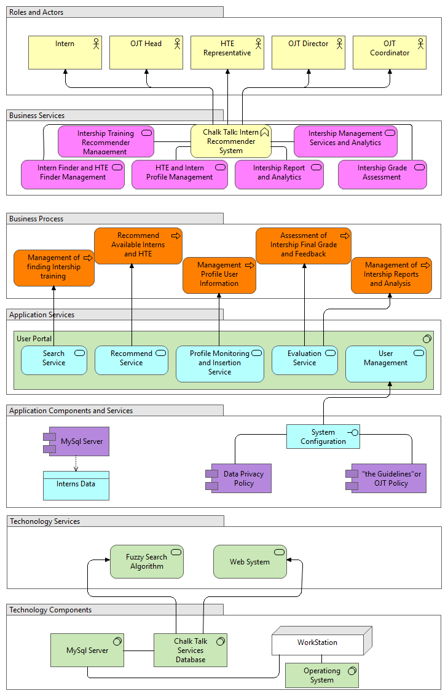

**Figure 1**

System Architecture Overview of ChalkTalk: Internship Recommender System

The figure shows the components of the development of a Chalk Talk: Internship Recommender System. It has 7 classifications consist of the roles and actors, business services, business process, application services, application components and services, technology services and technology components. There are 5 important users of the system. These are the Intern, OJT Head, HTE Representative, OJT Coordinator and OJT Director.

In the business services, Chalk Talk includes Internship Training Recommender Management Services, Intern Finder and HTE Finder Management, Intern and HTE Profile Management, Internship Management Services and Analytics, Internship reports and analytics, and last is the Assessment of Internship Grade Performance. According to the business process, the purpose of the system is to find internship training for the Intern and HTE business enterprise. The system must have a feature for finding internship training by recommending available interns and HTE based on some classifications and then managing the profile of the beneficiary/user of the system. After the training, the system needs to have an assessment of internship final grade and feedback by using internship analysis and reports.

For the application services, it has 6 modules services such as search service, recommend service, profile monitoring and insertion service, evaluation service and user management services. The system used MySQL Server for storing the data of the intern and HTE business enterprise and creates a System Configuration to update the Data Privacy Act and the “Guidelines” or the OJT policy.

The system used technology services such as fuzzy search algorithm and Web system. There are 4 technology components involved in the system, these are MySQL Server, Chalk Talk Services Database and the Workstation for the operating system.

* + 1. **Business Process Architecture**

Business process is visualized through BPMN or the Business Process Modeling Notation.

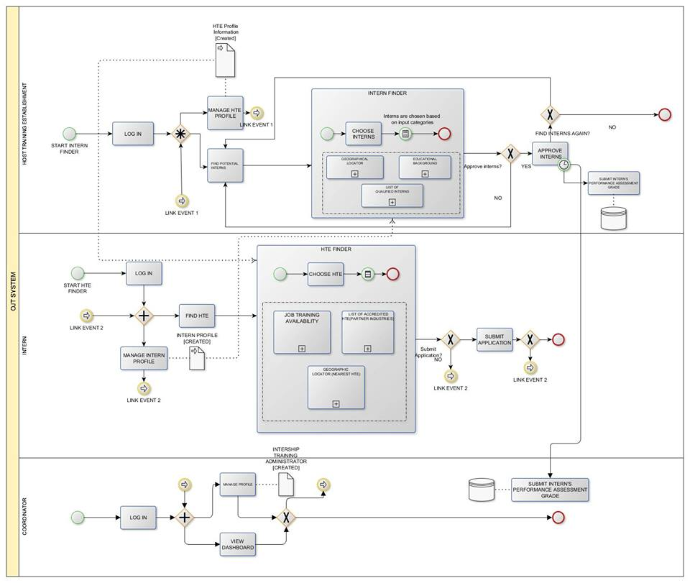

**Figure 2**

Business Architecture of ChalkTalk: Internship Recommender System

* + 1. **Application Architecture**

Application architecture diagram can summarize the details of the system by outlaying its components and on how the user will interact to it.

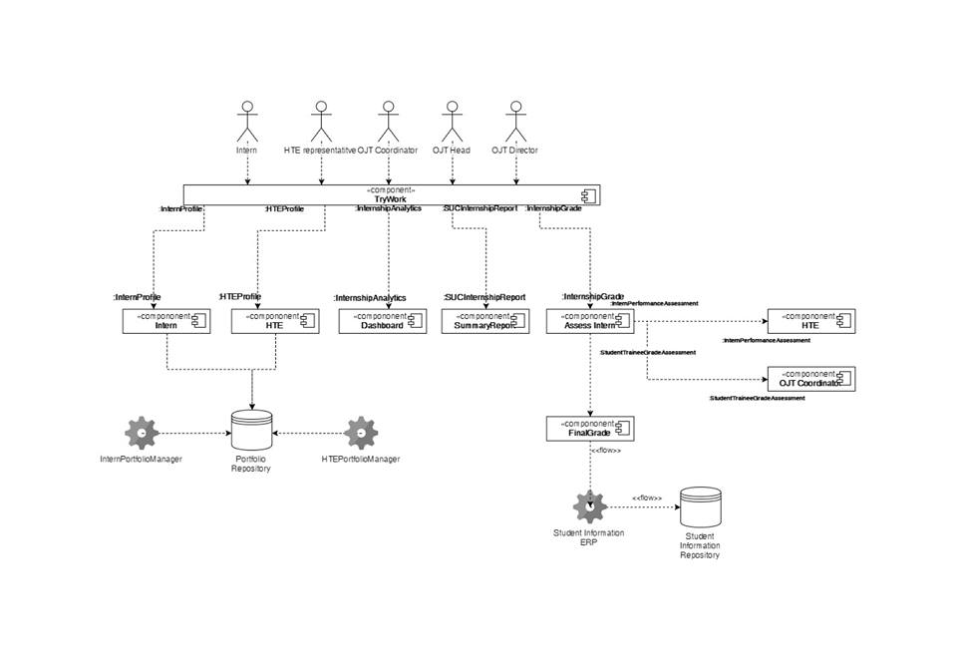

**Figure n**

Application Architecture of ChalkTalk: Internship Recommender System

* + 1. **Data Architecture**

This architecture defines how the data is organized and how the relations among them are associated. It formulates all the constraints that are to be appliedon the data.

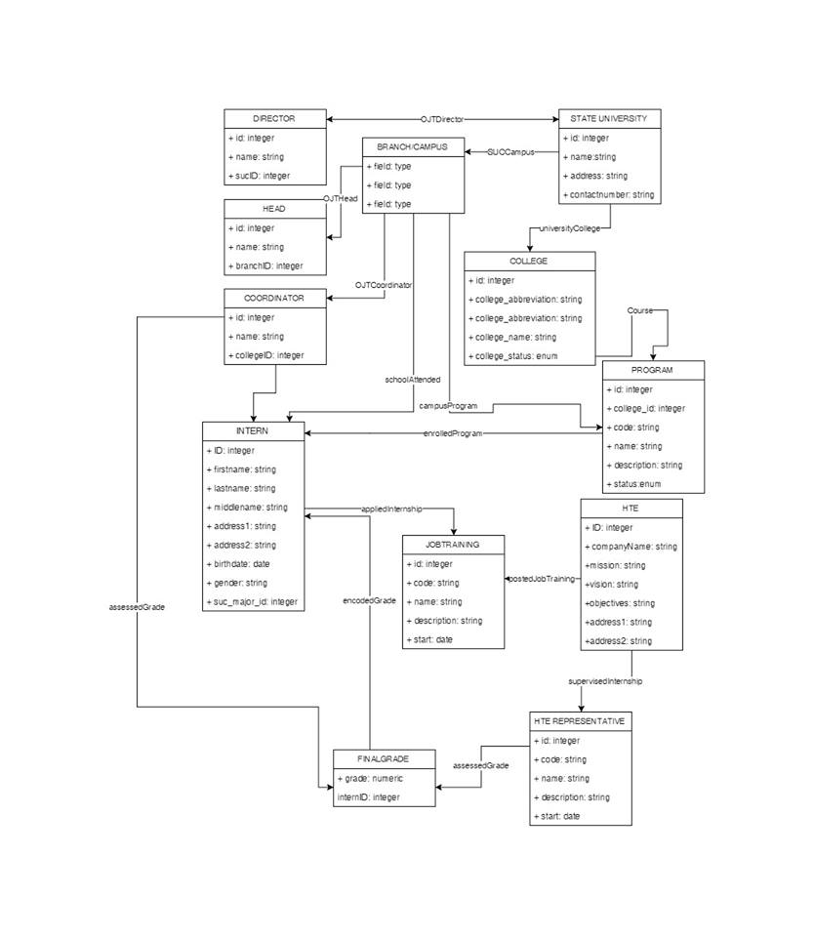

**Figure n**

Data Architecture of ChalkTalk: Internship Recommender System

* + 1. **Technology Architecture**

Technology architecture shows the process of development by the use of methodical information technology specifications, models and guidelines, using a variety of Information Technology notations.

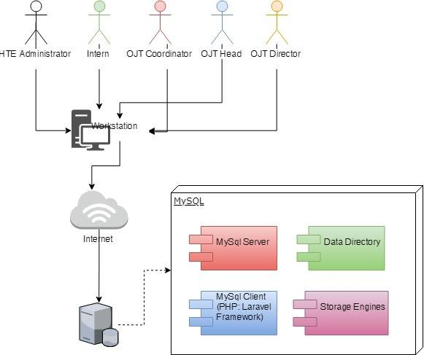

**Figure n**

Technology Architecture of ChalkTalk: Internship Recommender System

1. **Product Backlog**
   1. **Product Backlog (User Stories) Table**

**Table 11**

Product Backlog – User Stories

|  |  |  |  |  |
| --- | --- | --- | --- | --- |
| USER STORY NUMBER | USER STORIES | USER STORIES PRIORITY | REVISED PRIORITY | STATUS |
| End User Profile Information | | | | |
| User Role: Intern | | | | |
| 1 | As a Student, I must be able to enter a referral code to gain access to the system. | 3 | - | DONE |
| 2 | As a Student, I must be able to login first to access the system. | 1 | - | DONE |
| 3 | As a Student, I must be directed to the homepage after logging in. | 1 | - | DONE |
| 4 | As a Student, I must be able to navigate the system using the given navigation buttons. | 1 | - | DONE |
| 5 | As a Student, I must be able to view my profile in the system. | 2 | - | DONE |
| 6 | As a Student, I must be able to edit my profile in the system. | 2 | - | DONE |
| 7 | As a Student, I must be able to modify my information for my resume. | 2 | - | DONE |
| 8 | As a Student, I must be able to generate a resume. | 3 | - | DONE |
| 9 | As a Student, I must be able to see the profile of the Host Training Establishment. | 2 | - | DONE |
| User Role: Host Training Establishment | | | | |
|  | As a Company Admin, I must be able to register to the system. | 3 | - | DONE |
|  | As a Company Admin, I must be able to login first to access the system. | 1 | - | DONE |
|  | As a Company Admin, I must be directed to the homepage after logging in. | 1 | - | DONE |
| User Role: OJT Coordinator | | | | |
|  | As a Coordinator, I must be able to register to the system. | 3 | - | DONE |
|  | As a Coordinator, I must be able to login first to access the system. | 1 | - | DONE |
|  | As a Coordinator, I must be directed to the homepage after logging in. | 1 | - | DONE |
|  | As a Coordinator, I must be able to add or import current enrolled students for OJT. | 1 | - | DONE |
| User Role: OJT Head | | | | |
|  | As an OJT Head, I must be able to register to the system. | 3 | - | DONE |
|  | As an OJT Head, I must be able to login first to access the system. | 1 | - | DONE |
|  | As an OJT Head, I must be directed to the homepage after logging in. | 1 | - | DONE |
| User Role: OJT Director | | | | |
|  | As an OJT Director, I must be able to register to the system. | 3 | - | DONE |
|  | As an OJT Director, I must be able to login first to access the system. | 1 | - | DONE |
|  | As an OJT Director, I must be directed to the homepage after logging in. | 1 | - | DONE |
| HTE Finder | | | | |
| User Role: Intern | | | | |
|  | As a Student, I must be able to view companies who are a match for my OJT to view my options for my on-the-job training. | 1 | - | DONE |
|  | As a Student, I must be able to submit Internship Application to every Host Training Establishments available or with my preference. | 2 | - | DONE |
|  | As a Student, I must be able to see if a company has accepted my application for OJT. | 1 | - | DONE |
|  | As a Student, I must be able to see the status of all of my applications. | 2 | - | DONE |
|  | As a Student, I must be able to see the timeline of the application status for each Job Trainings I applied. | 2 | - | DONE |
|  | As a Student, I must be able to find the nearest Host Training Establishment according to: Region, Province, and Town. | 2 | - | DONE |
|  | As a Student, I must be able to search Host Training Establishments. | 3 | - | DONE |
| Intern Finder | | | | |
| User Role: Host Training Establishment | | | | |
|  | As a Company Admin, I want to see how the system intelligently suggests who are the most qualified potential interns according to: Skills, General Point Average in Academics, State University / College. Personal Identity of an Intern is hidden to avoid bias results. | 1 | - | DONE |
|  | As a Company Admin, I want to choose from applications of OJT based on qualifications. | 2 | - | DONE |
|  | As a Company Admin, I want to accept applications of OJT based on qualifications. | 2 | - | DONE |
|  | As a Company Admin, I want to assess the application of the Intern. | 2 | - | DONE |
|  | As a Company Admin, I want to find the nearest potential interns available. | 2 | - | DONE |
|  | As a Company Admin, I want to find specific interns according to: Region, Province, Town, and State University. | 2 | - | DONE |
|  | As a Company Admin, I want to view information of available potential interns according to: State University, Degree Programs, ans Skills Major / Field of Specialization. | 1 | - | DONE |
|  | As a Company Admin, I want to provide HTE information based on the following requirements such as: Company Profile, List of available Job Training and Job Description, Official Company Address, Official Contact Number, Human Resource - Head Information, Training Supervisor Information. | 3 | - | DONE |
| Coordinator Services | | | | |
| User Role: OJT Coordinator | | | | |
|  | As a Coordinator, I must be able to view the total number of affiliated host training companies | 2 | - | DONE |
|  | As a Coordinator, I must be able to give referral code that will be use by the student for account setup | 2 | - | DONE |
|  | As a Coordinator, I must be able to pre-assess students that are approved for internship deployment | 2 | - | DONE |
|  | As a Coordinator, I must be able to add companies to the list of OJT companies, if necessary | 2 | - | DONE |
| Internship Grade Assessment | | | | |
| User Role: Host Training Establishment | | | | |
|  | As a Company Admin, I want to set the grade of the Intern that applied in our company. | 2 | - | DONE |
|  | As a Company Admin, I want to add remarks about the Intern after he/she finished the Internship. | 2 | - | DONE |
| User Role: OJT Coordinator | | | | |
|  | As a Coordinator, I must be able to grade student trainees after the Internship. | 3 | - | DONE |
|  | As a Coordinator, I must be able to add remarks about the feedback after he/she finished the Internship Program. | 3 | - | DONE |
| Internship Reports and Analytics | | | | |
| User Role: OJT Coordinator | | | | |
|  | As a Coordinator, I must be able to view the total number of students enrolled under the college for the current academic year and semester. | 1 | - | DONE |
|  | As a Coordinator, I must be able to view reports, to keep track of the OJT affairs | 2 | - | DONE |
|  | As a Coordinator, I must be able to view the overall enrolled student trainee that are job- per degree program | 1 | - | DONE |
|  | As a Coordinator, I must be able to see OJT applications which have not matched applications with a company | 3 | - | DONE |
|  | As a Coordinator, I must be able to view the comparison rate of enrolled students, deployed for internship, and completed their internship | 1 | - | DONE |
|  | As a Coordinator, I must be able to see what companies have matched OJT applications of students | 3 | - | DONE |
| User Role: OJT Head | | | | |
|  | As an OJT Head, I must be able to view the total number of students enrolled in the SUC campus/branch for the current academic year and semester | 1 | - | DONE |
|  | As an OJT Head, I must be able to view the overall enrolled student trainee per degree program | 2 | - | DONE |
|  | As an OJT Head, I must be able to view the total number of affiliated host training companies | 3 | - | DONE |
|  | As an OJT Head, I must be able to view the overall internship enrollment in the SUC campus/branch I am assigned | 3 | - | DONE |
|  | As an OJT Head, I must be able to view the overall internship enrollment per college | 3 | - | DONE |
|  | As an OJT Head, I must be able to view the overall internship enrollment per degree program | 3 | - | DONE |
| User Role: OJT Director | | | | |
|  | As an OJT Director, I must be able to view the total number of students enrolled for the current academic year and semester | 1 | - | DONE |
|  | As an OJT Director, I must be able to view the overall internship enrollment per campus/branch | 2 | - | DONE |
|  | As an OJT Director, I must be able to view the overall internship enrollment in the SUC. | 1 | - | DONE |
|  | As an OJT Director, I must be able to view the overall internship enrollment per college. | 2 | - | DONE |
|  | As an OJT Director, I must be able to view the overall internship enrollment per degree program. | 2 | - | DONE |

* 1. **Product Backlog for EIS Information Security**

**Table 12**

Product Backlog – EIS Information Security

|  |  |  |  |  |
| --- | --- | --- | --- | --- |
| USER STORY NUMBER | USER STORIES | USER STORIES PRIORITY | REVISED PRIORITY | STATUS |
| 1 | As a product owner, I want to have a login page so that only the authorized individuals can access the system. | 1 | - | DONE |
| 2 | As a product owner, I want that the usernames be unique for every user to avoid duplication of data. | 1 | - | DONE |
| 3 | As a product owner, I want to restrict my users from accessing information beyond their role to avoid any disclosure of sensitive data. | 1 | - | DONE |
| 4 | As a product owner, I want to verify that the user has an access only to the resources/page which they are authorized to use. | 1 | - | DONE |
| 5 | As a product owner, I want that the password of my users be masked to hide the actual password from intruders. | 1 | - | DONE |
| 6 | As a product owner, I want that the password provided by the users upon registration must have a minimum of 8 characters. | 1 | - | DONE |
| 7 | As an Administrator, I want to create a password recovery in case I forgot the password. | 1 | - | DONE |
| 8 | As a product owner, I want to verify inputs from the users to ensure that all information entered are valid. | 1 | - | DONE |
| 9 | As a product owner, I want that the sensitive information stored in the database be hashed/encrypted. in order to secure confidentiality. | 1 | - | DONE |
| 10 | As a product owner, I want my developers to ensure that the algorithm for encryption is not broken or risky. | 1 | - | DONE |
| 11 | As a product owner, I want to ensure that no sensitive information is exposed through error messages. | 1 | - | DONE |
| 12 | As a product owner, I want the system to ensure that no invalid types are accepted when uploading. | 1 | - | DONE |
| 13 | As a product owner, I want to ensure that the information shown to the users are related to their profession. No sensitive information shall be shown to the users. | 1 | - | DONE |
| 14 | As a product owner, I want to have a smooth handling of all the exceptions to any transactions. | 1 | - | DONE |
| 15 | As a product owner, I want to have a proper/correct conversion of any numeric type in order to avoid conflicts. | 1 | - | DONE |
| 16 | As a product owner, I want my website to be published in a secure domain to avoid any sensitive information exposure. | 1 | - | DONE |
| 17 | As a product owner, I want the users to be automatically logged out of the system once the tab is closed, whether it may be accidentally or not, in order to protect users from others. (session) | 1 | - | DONE |

* 1. **Product Backlog for EIS Standards**

**Table 13**

Product Backlog – EIS Standards

|  |  |  |  |  |
| --- | --- | --- | --- | --- |
| USER STORY NUMBER | USER STORIES | USER STORIES PRIORITY | REVISED PRIORITY | STATUS |
| 1 | As a product owner, I want the navigation of the website to be on top. | 1 | - | DONE |
| 2 | As a product owner, I want a dropdown button for showing the subs of the navigation. | 1 | - | DONE |
| 3 | As a product owner, I want to see on what page I am currently in the system and what page I had been before. (breadcrumbs) | 2 | - | DONE |
| 4 | As a system user, I want fields with choices that only need one selection (such as sex: M, F) to be a radio button and multiple selections to be checkboxes. | 1 | - | DONE |
| 5 | As a system/ website user, I want input of dates come from a date picker for easier selection or input to field. | 1 | - | DONE |
| 6 | As a system/ website user, I want all the fields in the forms to be aligned and organized in a way that will prevent any confusion and distastes. | 1 | - | DONE |
| 7 | As a product owner I want the icons to be consistent in every page with its design depending on its function. | 1 | - | DONE |
| 8 | As a product owner I want the icons to be consistent in every page with its color depending on its function. | 2 | - | DONE |
| 9 | As a product owner I want the buttons to be consistent in every page with its design depending on its function. | 2 | - | DONE |
| 10 | As a product owner I want the buttons to be consistent in every page with its color depending on its function. | 2 | - | DONE |
| 11 | As a product owner, I want the logo of the LGU be placed on the upper-left of the header. | 2 | - | DONE |
| 12 | As a system/ website user, I want the design of the modals to be consistent in every page. | 1 | - | DONE |

### 2.3.1 UI/UX (icons, color, etc)

**Input Controls**

**Table 14**

UI/UX – Standard Input Controls

|  |  |  |
| --- | --- | --- |
| ELEMENTS | DESCRIPTION | EXAMPLES |
| Combo Boxes | A component that combines button or editable field and a drop-down list. |  |
| Buttons | An implementation of a push button to trigger an action if the user clicks it. |  |
| Text fields | A text component that allows editing of a single line of non-formatted text. |  |
| Date fields | A component use for choosing year, month, day. |  |
| Text Area | A multiline text area that displays plain text. |  |

**Navigational Components**

**Table 15**

UI/UX – Standard Navigational Components

|  |  |  |
| --- | --- | --- |
| ELEMENTS | DESCRIPTION | EXAMPLES |
| Search Field | Used for searching important data. |  |
| Date Picker | Used for viewing of schedule. |  |

**Color**

**Table 16**

UI/UX – Standard Color

|  |  |  |
| --- | --- | --- |
| ELEMENTS | DESCRIPTION | EXAMPLES |
| Blue, Light Gray | These are the colors used in user -interface of the system. |  |
| Black | A color use in text. |  |

### 2.3.2 Messages

**Table 17**

Messages Standards

|  |  |
| --- | --- |
| DESCRIPTION | EXAMPLE |
| User is successfully inserted |  |
| User is successfully updated |  |
| Seminar successfully inserted |  |

### 2.3.3 Database

**Table 18**

Product Backlog – Database EIS Standards

|  |  |  |  |  |
| --- | --- | --- | --- | --- |
| USER STORY NUMBER | USER STORIES | USER STORIES PRIORITY | REVISED PRIORITY | STATUS |
| 1 | As a product owner, I want to have a centralized database of the system. | 1 | - | DONE |
| 2 | As a system administrator, I want to have a consistent naming of data tables. | 1 | - | DONE |
| 3 | As a system administrator, I want to have a consistent naming of table attributes. | 1 | - | DONE |
| 4 | As a system administrator, I want the database to have consistent key relationships. | 1 | - | DONE |
| 5 | As a system administrator, I want to have a consistent data type. | 1 | - | DONE |
| 6 | As a system administrator, I want to have a consistent data format. | 1 | - | DONE |
| 7 | As a system administrator, I want not required fields to be nullable. | 1 | - | DONE |
| 8 | As a system administrator, I want required fields not to allow null values. | 1 | - | DONE |
| 9 | As a database administrator, I want to have a database model. | 1 | - | DONE |
| 10 | As a database administrator, I want to be able to model the database. | 1 | - | DONE |

* 1. **Product Backlog for EIS Integration**

**Table 19**

Product Backlog – EIS Integration

|  |  |  |  |  |
| --- | --- | --- | --- | --- |
| USER STORY NUMBER | USER STORIES | USER STORIES PRIORITY | REVISED PRIORITY | STATUS |
| 1 | As a Student, I want to apply to the chosen HTEs that are available. | 2 | - | DONE |
| 2 | As a Coordinator, I want to set partnerships within the chosen HTEs via a Memorandum of Agreement | 2 | - | DONE |
| 3 | As a Coordinator, I must be able to see what companies have matched OJT applications of students | 2 | - | DONE |

* 1. **Product Backlog for Analytics**
     1. **Dashboards**

**Table 20**

Product Backlog - Dashboards

|  |  |  |  |  |
| --- | --- | --- | --- | --- |
| USER STORY NUMBER | USER STORIES | USER STORIES PRIORITY | REVISED PRIORITY | STATUS |
| 1 | As a Coordinator, I must be able to see OJT applications which have not matched applications with a company | 2 | - | DONE |
| 2 | As a Coordinator, I must be able to view the total number of affiliated host training companies | 2 | - | DONE |
| 3 | As a Coordinator, I must be able to view the comparison rate of enrolled students, deployed for internship, and completed their internship | 2 | - | DONE |

### Reports

**Table 21**

Product Backlog – Reports

|  |  |  |  |  |
| --- | --- | --- | --- | --- |
| USER STORY NUMBER | USER STORIES | USER STORIES PRIORITY | REVISED PRIORITY | STATUS |
| 1 | As a Coordinator, I want to filter and print the total number of all intern lists. | 2 | - | DONE |
| 2 | As a Coordinator, I want to filter and print the OJT Placement of the intern. | 2 | - | DONE |
| 3 | As a Coordinator, I want to filter and print the industries that are affiliated with the university | 2 | - | DONE |

1. **Sprint Backlog**
   1. **Sprint Backlog (User Stories) Table**

**Table 21**

Sprint Backlog – User Stories

* + 1. **Information Security**

**Table 23**

Sprint Backlog – Information Security

* + 1. **EIS Standards**

**Table 24**

Sprint Backlog – EIS Standards

* + 1. **EIS Standards**

**Table 24**

Sprint Backlog – EIS Standards

* + 1. **Analytics**

**Table 26**

Sprint Backlog - Analytics

* 1. **Sprint Burndown Chart**
  2. **Sprint Backlog Output**
     1. **Requirement Traceability Matrix**
     2. **Data Dictionary**
     3. **Test Scripts**
     4. **System Screenshots**

**A. Web Application**

1. **Application System User Manual**
   1. **GENERAL INFORMATION**

This section provides basic information about the system and the needed components to be installed in your computer in order to run.

* + 1. **System Overview**

ChalkTalk: Internship Recommender System (CT: IRS) is an application that provides fast servicing for its applicants with the use of web application.

* + 1. **Authorized Use Permission**

This user’s manual is subject to copyright policy. Unauthorized modification, reproduction or infringement of this document is strictly prohibited.

* + 1. **Points of Contact**

Any concern relating to the functionality and condition of the system or in case of emergency, you may contact the System Developers.

|  |  |  |
| --- | --- | --- |
| NAME | EMAIL ADDRESS | CONTACT NUMBER |
| 1. Joshua Miguel Magtibay | [joshuamiguelmagtibay17@gmail.com](mailto:clarkianwoods@gmail.com) | +639771949779 |
| 1. Oliver Gabriel | [-](mailto:jeremiahvigan3011@gmail.com) | - |
| 1. Mary Joy Asusula | [-](mailto:jeremiahvigan3011@gmail.com) | - |
| 1. Peter John Teneza | [-](mailto:emcrstnacrdnas08@gmail.com) | - |
| 1. Keith Eyvan Alvior | [-](mailto:mnvalencia17@gmail.com) | - |
| 1. Lowell Dave Agnir | [-](mailto:jeremiahvigan3011@gmail.com) | - |

* + 1. **Important Terms and their Definition**

|  |  |
| --- | --- |
| TERMS | DEFINITION |
| Hostgator Web Hosting | A hosting service which offers powerful and affordable website and cloud hosting services. |
| Laravel Framework | Laravel is a free, open-source PHP web framework, created by Taylor Otwell and intended for the development of web applications following the model–view–controller architectural pattern and based on Symfony. |
| PHPStorm | An integrated development environment (IDE) used in computer programming, and is the most widely used PHP IDE. |

* 1. **SYSTEM SUMMARY**

This section provides brief information of how the system works.

* + 1. **System Configuration**

ChalkTalk: Internship Recommender System (CT: IRS) requires minimum hardware and software requirements and will run smoothly in all windows application.

* + 1. **User Access**

PAEIS application has many user access rights.

|  |  |
| --- | --- |
| USER | ACCESS RIGHTS |
| Intern | This user can access the HTE Finder. |
| Host Training Establishment Representative/Supervisor | This user can Access the Intern Finder and Job Trainings Management. They are the one that grades the intern first, signifying the end of the internship. |
| OJT Coordinator | This user can add interns that qualified for the internship program. Can access the Pre-Assessment and the Analytics and Reports. |
| OJT Head | This user can monitor the interns on the college through Analytics and Reports. |
| OJT Director | This user can monitor the interns on all of the branches of the colleges through Analytics and Reports. |

**4.2.4 Contingencies and Alternate Modes of Operation**

In the event of emergency, disaster, or accident website may encounter server problem which may cause the website go into an error, Stone Flair Hotel Information System may be transferred and operated on a different computer and serve as its sole server to keep the continuity of the system service.

* 1. **Getting Started**

This section provides a simple step by step guide on how to operate the ChalkTalk: Internship Recommender System (CT: IRS) in your computer.

* + 1. **Logging In**

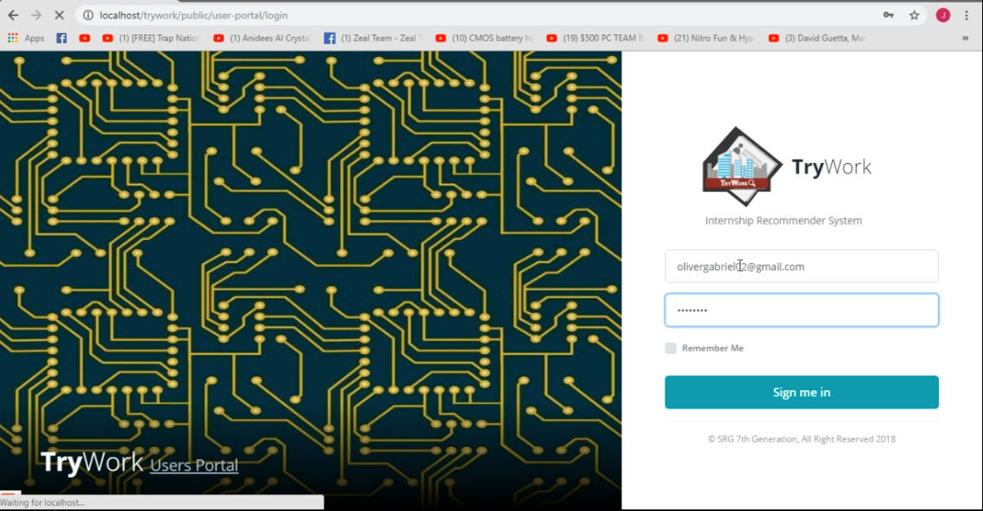In order to access the ChalkTalk: Internship Recommender System (CT: IRS), a valid username and password must be provided in the textboxes.

a. Type Email here

b. Type Password here

c. Click to Sign in

* + 1. **System Application Menu**

In order to access the ChalkTalk: Internship Recommender System (CT: IRS), a valid username and password must be provided in the textboxes.

1. **Recommendations and Conclusion**

ChalkTalk: Internship Recommender System definitely requires time and effort to learn and develop. Adapting Agile Scrum methodology, it helped the developers manage their time strictly and organize necessary tasks properly. Together with the resources which the team has interviewed, the team managed to develop a working Information System. Time management and proper dissemination of tasks to each team member are effective practices to get ahead a project using the Agile Scrum approach.

Local Government Unit – Public Assistance Enterprise Information System will benefit local government unit in maintaining their good service to the public. Managing, processing and storing data will be not an issue anymore. Local Government Unit – Public Assistance Enterprise Information System is a web-based enterprise information system which supports a Local Government Unit in providing Business Permits and Licenses, Motorized Tricycle Operators Permit, Assessment and Collection of Taxes as well as monitoring its revenue.

As a team, we recommend Local Government Units in the Philippines to use an automated system for their business processes. Also, the team suggests that LGU systems must be developed in web-based platform to increase participative governance between the public servants and citizenry.

To the student and future developers, the team commends them use Agile Scrum also and always apply teamwork, cooperation, patience, communication and passion, for these will be the gateway for them to achieve a successful project.

# Appendix A

Adviser Acceptance

# Appendix B

Panel’s Evaluation and Signature

# Appendix C

Plot Company and Background

# Appendix D

APA Format

# Appendix E

Comparison of the EIS to the existing EIS

# Appendix F

Code Listings

# Appendix G

Code Listings